OODP HW2

21300691 WonSikCheung

User’s Manual

1. Compile java file
   1. > javac \*.java
2. Run AtmSimulator
   1. > java AtmSimulator
   2. Type Initial Balance(0~100) and The number of family members(1~6)
3. Result

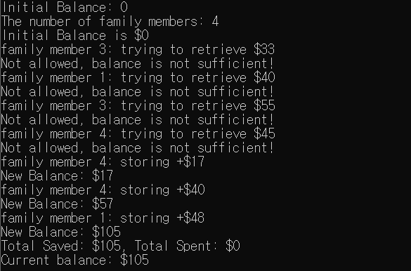

UML

